Minutes of the CIOMS GGPRI WG in-person Meeting in Geneva (10-12 November 2022)

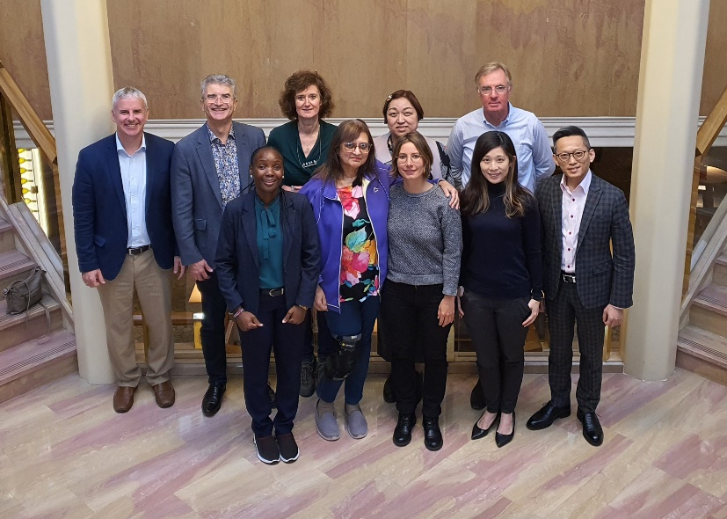

Presents:
Winfred Badanga (Uganda National Council of Science and Technology), Ames Dhai (University of Witwatersrand), Kim Ellefsen-Lavoie (Lausanne University Hospital), Kotone Matsuyama (International Federation of Associations of Pharmaceutical Physicians and Pharmaceutical Medicine), Lembit Rägo (CIOMS), Raffaella Ravinetto (Antwerp Institute of Tropical Medicine), Andreas Reis (WHO), Aline Sigrist (University of Neuchâtel), Dominique Sprumont (World Medical Association), Johannes van Delden (University of Utrecht), Creany Wong (The University of Hong Kong), Henry Yau (The International Clinical Trial Center Network).

Excused:
Anant Bhan (Yenepoya University), Christine Grady (Department of Bioethics NIH Clinical Center), Marie Hirtle (McGill University Health Centre), Dirk Lanzerath (European Network of Research Ethics Associations), Morenike Folayan (New HIV Vaccine and Microbicide Advocacy Society), Rosanna Lagos (Roberto del Río Children's Hospital), Roli Mathur (Indian Council of Medical Research), Zhu Wei (Shanghai Ethics Committee for Clinical Research).

Thursday 10th:
The meeting started with welcome and opening remarks by Dominique Sprumont, and Lembit Rägo.
Dominique Sprumont briefly presented the draft report structure and introduction (see on the GGPRI WG shared folder: CIOMS_Guidelines on Good Governance Practice for Research Institutions_1.1_071122; CIOMS-GGPRI-5th-WG-meeting_Geneva_11.22-1.pptx).
The leaders of each subgroup presented the work done in their subgroup, the organisation, the difficulties encountered and the consolidated draft (see on the GGPRI WG shared folder: CIOMS-GGPRI_SG_law-ethics.pptx; CIOMS-meeting-Subgroup-2_10112022.pptx; CIOMS_GGPRI_WG-Meeting_SG3_221110_Final1.pptx; 221109_Discussion-points_SG4.pptx).
The afternoon ended with a general discussion about the consolidated drafts and the organization of Friday’s meeting.

Friday 11th:

The WG group discussed the outcomes of the Day 1 and how to organize the work on the different chapters. First, the WG focused on the order of the chapters to be better expressing our priorities. Here is the new structure that will be applied to the next version of the draft:
  - Management
  - Ethics
  - Law
  - Research integrity & Conflict of interests
  - Scientific standards
  - Collection, storage and use of data and biological materials:
    - Biobanks & Registries
    - Data Handling & Information Technology (IT)
  - Budget & Financing
  - Collaboration
  - Communication
  - Qualification & Training
  - Oversight
The name of certain chapters was discussed with the main concern not to use clinical trial jargon. The WG insisted on the need to cover all health-related research involving human participants, acknowledging the fact most of those research are not clinical trials and that the document should also explicitly cover observational studies, research in human and social sciences and qualitative research. Then the WG split up in two groups to work on the different chapters, Dominique Sprumont and Aline Sigrist creating bridges between them.

Group 1 (green):
- Ames Dhai
- Hans van Delden (rapporteur)
- Raffaella Ravinetto
- Andreas Reis
- Vladislava Talanova (PhD student working on the governance biobank under the direction of Dominique Sprumont, who participated with Kim Ellefsen-Lavoie in the drafting of the chapter on Biobanks&Registries).
Group 2 (yellow):
- Winfred Badanga
- Kotone Matsuyama
- Creany Wong
- Henry Yau (rapporteur)
In the afternoon, some WG members who couldn’t be present in Geneva joined for a websession (Anant Bhan; Dirk Lanzerath; Rosanna Lagos; Francine Ntoumi; Zhu Wei). Dominique presented the outcomes of the meeting and the discussions, and each member online gave their opinion and questions about the draft report. Everyone expressed their support on the direction taken by the document which integrated the concerns they shared in previous meeting. The remarks from the online participants were taken into consideration in the following discussion as it should be visible in the next version of the document. The day finished with a brief general discussion to organize the work of the last day.

Saturday, 12th:

Group 1 and 2 presented the results of the work done on Friday (see on the GGPRI WG shared folder: Group 1_Summary of Discussion_Chapters Revision.pptx; Group 2_Summary of Discussion_Chapters Revision.pptx). A general discussion followed the two presentations to consolidate the important points for the revision of the chapters. A strong consensus came out on the fact the document should be more aspirational than prescriptive, that the WG should make extensive use of existing guidelines by referring systematically to them (see GGPRI WG shared folder), that the wording of the document should be addressing directly the institutions involved in health-related research and that, when ever feasible, the document should highlight the direct interests of those institutions to improve their good governance practice of research involving human participants. Members of the WG are also strongly invited to identify key stakeholders to involve in the consultation and inform them in advance on our work. Efforts are as well necessary to coordinate with current initiatives in the field of research ethics (revision of the DoH, WHO Tool for Benchmarking Ethics Oversight and the answer to May 22 WHA Resolution on Strengthening clinical trials (see GGPRI WG shared folder: WHA_Resolution on clinical trial_A75_R8-en.pdf). Andreas Reis will keep us posted on the two later. We should identify key events and conferences where our work could be presented and discussed. The WG finally agreed to no longer work in sub-groups and to share all documents, when ready, to the full WG.

The agenda for the continuation of the GGPRI WG was discuss and revised as follows:

November 28, 2022:

Revision of the chapters based on the discussion during the GGPRI WG In-site meeting in Geneva. The subgroups’ leaders agreed to work on the draft to be send to Dominique:
- Introduction: Dominique Sprumont
- Chapter 2: Hans van Delden
- Chapter 1 & 3 & 4: Kim Ellefsen-Lavoie
- Chapter 5 & 9 & 10: Henry Yau & Creany Wong
- Chapter 6 & 7 & 8: Kotone Matsuyama
(Chapters numbering corresponds to the version of the document as presented at the opening of the meeting, namely CIOMS_Guidelines on Good Governance Practice for Research Institutions_1.1_071122)

December 19, 2022:

Collated draft of the guidelines (Dominique Sprumont)

January 16, 2023:

Feedbacks of the GGPRI WG members on the collated draft

January 30 2023 or February 6, 2023:

GGPRI WG full meeting online

February 28, 2023:

Launch of the public consultation

April 10 or 24, 2023:

End of the consultation

August/September 2023:

In-person meeting to finalize the document (a June/July 2023 meeting could also be an option depending on how the consultation moves on, but this seems very optimistic)

